COURSE OUTLINE

MMC120

Communicative Writing

3 CREDITS

PREPARED BY: Hillarie Zimmermann, Instructor DATE: December 19, 2019

APPROVED BY: Stephen Mooney, Interim Dean DATE: December 24, 2019

APPROVED BY ACADEMIC COUNCIL: October 7, 2014
RENEWED BY ACADEMIC COUNCIL: Click or tap to enter a date

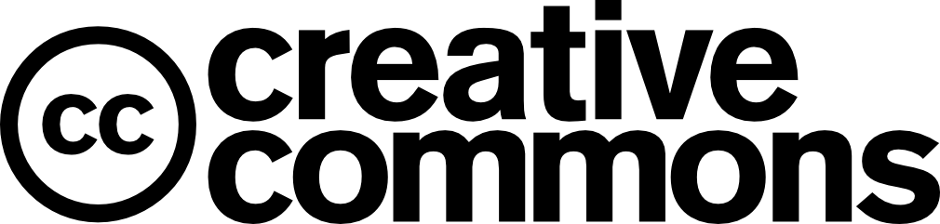

This work is licensed under the Creative Commons Attribution-NonCommercial-ShareAlike 4.0 International License. To view a copy of this license, visit http://creativecommons.org/licenses/by-nc-sa/4.0/.

Version 1.2 revised and approved by Academic Council: April 17, 2019
Academic Council, Governance Office
Academic Council MyYC: Policies, Procedures and Forms

COMMUNICATIVE WRITING

INSTRUCTOR: Hillarie Zimmermann OFFICE HOURS: Tuesday 10:00 to noon

OFFICE LOCATION: A2431 CLASSROOM: T1030A

E-MAIL: hzimmermann@yukoncollege.yk.ca TIME: 1:00 – 4:00 p.m.

TELEPHONE: (867) 668-8758 DATES: January 9 to April 16, 2020

COURSE DESCRIPTION

Success in multimedia communications depends largely on the effectiveness of written messages. This course will prepare you to write engaging scripts for various media, including writing for print, radio, television, and web. You will be encouraged to improve the quality of your writing by focusing on target audience, diplomacy, organization and grammar. In addition, peer reviewing and editing of drafts will help you develop an appreciation for the writing process and the skills needed to critically evaluate your own work. You will finish the course with samples of industry-relevant creative writing that can be added to your professional portfolios.

PREREQUISITES

None

RELATED COURSE REQUIREMENTS

None

EQUIVALENCY OR TRANSFERABILITY

AI GD 350 (3) AU ENGL 155 (3) CAPU SMNS 1xx (3)
COTR No Credit KPU SOBU 1xxx (3) NIC ENG 1xx (3)
SFU CMNS 2xx(3) TRU-OL CMNS 1xx1 (3) TWO COMM 100 lev (3)
UBCO No Credit UCW COMM 205 (3) UNBC SOSC 1xx (3)
UVIC WRIT 100 lev (1.5)

LEARNING OUTCOMES
Upon successful completion of the course, students will be able to:

- Write appropriately for a given medium and audience.
- Write for a variety of production genres including advertisements, news, public relations, and public service announcements.
- Write in an active voice.
- Edit for accuracy and brevity using editing and proofreading skills.
- Create strong writing samples for their future portfolios.

COURSE FORMAT

This is a classroom-based course. Classes will aim to be interactive and varied. In order to cater to a variety of learners, lectures using multimedia and group work will be employed.

ASSESSMENTS:
Weekly Writing Assignments:

Your weekly writing assignments make up 50% of your mark. Some of these will be brief take-home assignments, and some will be completed in class. These assignments will include:

 | Weekly Writing Assignments | % of Final Mark
1 | Media Advisory | 5
2 | Print News Release | 5
3 | Backgrounder and Fact Sheet | 5
4 | Strategic Message Planner | 7
5 | Radio Advertisement | 5
6 | Newsletter Story | 5
7 | Web Writing | 7
8 | Brochure | 5
9 | Print Ad | 6

Client/Portfolio Assignments:

Your client/portfolio (take-home) assignments will be for real clients. The writing you do for these clients will make up 50% of your mark. You are responsible for finding clients to work with for these assignments.

Client/Portfolio Assignments | % of Final Mark
Digital media kit (print news release, backgrounder, fact sheet). Select your own client. | 20
Integrated Advertising Project (strategic message planner; print ad; radio ad script; brochure or story) and presentation. Select your own client. | 30

EVALUATION:
Weekly Writing Assignments | 50%
Client/Portfolio Projects | 50%
Final Presentation | 0%  Must be completed to pass course
Total | 100%

REQUIRED TEXTBOOKS AND MATERIAL

Roberts, J. Writing for Strategic Communication Industries, The Ohio State University. This is an online textbook. It can be found online at - https://ohiostate.pressbooks.pub/stratcommwriting/

ACADEMIC AND STUDENT CONDUCT
Information on academic standing and student rights and responsibilities can be found in the current Academic Regulations that are posted on the Student Services/ Admissions & Registration web page.

PLAGIARISM
Plagiarism is a serious academic offence. Plagiarism occurs when students present the words of someone else as their own. Plagiarism can be the deliberate use of a whole piece of another person’s writing, but more frequently it occurs when students fail to acknowledge and document sources from which they have taken material. Whenever the words, research or ideas of others are directly quoted or paraphrased, they must be documented according to an accepted manuscript style (e.g., APA, CSE, MLA, etc.). Resubmitting a paper which has previously received credit is also considered plagiarism. Students who plagiarize material for assignments will receive a mark of zero (F) on the assignment and may fail the course. Plagiarism may also result in dismissal from a program of study or the College.

YUKON FIRST NATIONS CORE COMPETENCY
Yukon College recognizes that a greater understanding and awareness of Yukon First Nations history, culture and journey towards self-determination will help to build positive relationships among all Yukon citizens. As a result, to graduate from ANY Yukon College program, you will be required to achieve core competency in knowledge of Yukon First Nations. For details, please see www.yukoncollege.yk.ca/yfnccr.

ACADEMIC ACCOMMODATION
Reasonable accommodations are available for students requiring an academic accommodation to fully participate in this class. These accommodations are available for students with a documented disability, chronic condition or any other grounds specified in section 8.0 of the Yukon College Academic Regulations (available on the Yukon College website). It is the student’s responsibility to seek these accommodations. If a student requires an academic accommodation, he/she should contact the Learning Assistance Centre (LAC) at (867) 668-8785 or lassist@yukoncollege.yk.ca.

TOPIC OUTLINE
Date | Topic | Assignment/Project
Week 1  Jan. 9 | Introduction to class and get to know each other
Week 2  Jan. 16 | Overview of Strategic Writing and the Writing Process
Week 3  Jan. 23 | Public Relations & Media Advisories | Media Advisory due  Digital Media Kit begin
Week 4  Jan. 30 | Media Releases | Media Release due
Week 5  Feb. 6 | Backgrounder and Fact Sheets | Backgrounder and Fact Sheet due
Week 6  Feb. 13 | Working class | Instructor and peer feedback on Digital Media Kits
Week 7 Feb. 20 | Newsletter and Magazine Stories | Digital Media Kit Due  Newsletter Story due
Week 8  Feb. 27 | Web Writing | Web Writing due
Week 9  Mar. 5 | Brochures | Brochure due
Week 10  March 12 | Strategic Message Planners | Integrated Advertising Project (introduction)  Strategic Message Planner due
Week 11  March 26 | Radio Advertisements | Radio advertisements due
Week 12  Apr. 2 | Print Ads | Print Ad  DUE: IAP memo to instructor, specifying partner(s), client and product.
Week 13  Apr. 9 | Working class | Due: IAP strategic message planner  Instructor and peer feedback on IAPs and draft products
Week 14  Apr. 16 | Presentations | Presentations of Integrated Advertising Projects  IAPs due

