APPLIED ARTS DIVISION
School of Liberal Arts
Fall, 20xx

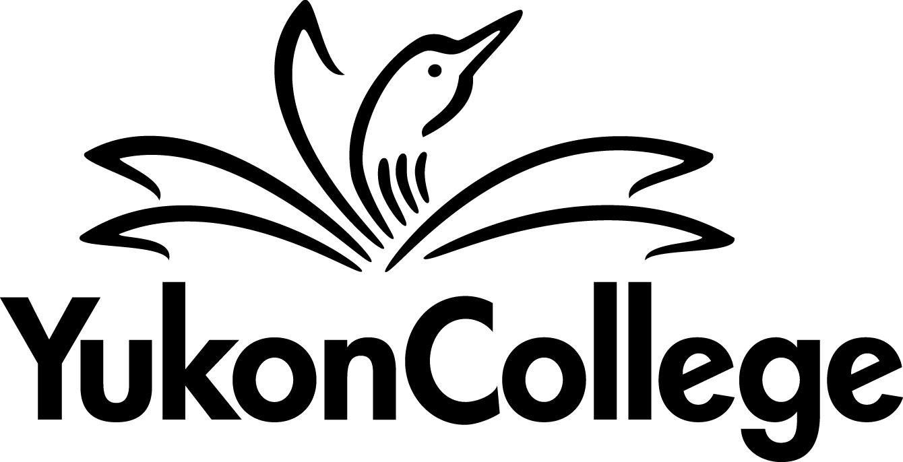

COURSE OUTLINE

FNGA 340

INDIGENOUS GOVERNANCE CAPSTONE

6 CREDITS

PREPARED BY: Lianne Charlie, Instructor DATE: March 31, 2017

APPROVED BY: Dr. Andrew Richardson, Dean DATE: May 16, 2017

APPROVED BY ACADEMIC COUNCIL: May 24, 2017

RENEWED BY ACADEMIC COUNCIL: (date)

This work is licensed under the Creative Commons Attribution-NonCommercial-ShareAlike 4.0 International License. To view a copy of this license, visit http://creativecommons.org/licenses/by-nc-sa/4.0/.
APPLIED ARTS DIVISION
FNGA 340
6 Credit Course
Fall Semester, 20xx

INDIGENOUS GOVERNANCE CAPSTONE

INSTRUCTOR: OFFICE HOURS:

OFFICE LOCATION: CLASSROOM:

E-MAIL: TIME:

TELEPHONE: DATES:

COURSE DESCRIPTION

The Indigenous Governance Capstone project is an opportunity for students to integrate theoretical knowledge of policy, governance and self-determination with practical methods in an applied setting. Students will work with various communities, non-governmental organizations (NGOs), governments, and organizations to develop a project proposal and will see the project through to successful completion.

PREREQUISITES
POLI 230 and FNGA 240

RELATED COURSE REQUIREMENTS
- FNGA 340 is two terms long. Both terms must be taken in succession
- FNGA 340 is reserved for students enrolled in the Bachelor of Arts (Indigenous Governance) degree
- Student must be in good academic standing (2.0 GPA) to register for FNGA 340

EQUIVALENCY OR TRANSFERABILITY
In progress

LEARNING OUTCOMES

Term 1: Land-based Activity
Upon successful completion of the course, students will be able to:
- Describe and demonstrate culturally respectful roles and responsibilities in Indigenous land-, language-, and culture-based work;
- Demonstrate land-, language- and culture-based skills and practices;
- Apply knowledge and skills gained from coursework to land-based activities;
- Compare and contrast the theoretical and practical components of Indigenous politics to on-the-ground experiences of Indigenous land-, language- and culture-based practices;

Term 2: Community Placements
Upon successful completion of the course, students will be able to:
- Describe and demonstrate culturally respectful roles and responsibilities in community placement;
- Demonstrate professional, theoretical and practical skills gained during placement;
- Apply knowledge and skills gained from coursework to everyday Indigenous politics;
- Compare and contrast the theoretical and practical components of Indigenous Politics to on-the-ground experiences of Indigenous modern governance, Indigenous community/Nation politics and Indigenous/state relations;
- Identify and analyse Indigenous theory (i.e. recognition politics, resurgence politics, self-determination, colonialism, etc.) in action in Indigenous modern governance, Indigenous community/Nation politics and Indigenous/State relations;
- Identify ways ancestral governance practices can inform, redefine, and/or be incorporated into Indigenous modern governance;
- Identify possible future positions, initiatives, and/or professions that align with their skill set and interests.

COURSE FORMAT:
Term One: Land-based Activity
Students will participate in a land-based activity co-facilitated by a community member(s) and the instructor. The Land-based Activity might be one of the following: tanning moose hide, canoe or backpacking trip, participating in fish camp, building a cache, cabin or out-building, setting traps, etc. The land-based activity will be determined by season/weather, availability of community facilitator(s), funding, and/or a request by a First Nation, and may require additional safety training. The time required for this course will depend on the Land-based Activity.

Term Two: Community Placement (CP)
Students will complete 40 hours of work experience with a community, organization, government, or Nation under the direct supervision of a Community Placement Supervisor. The 40 hours of work experience must be completed by the conclusion of Week 10 of Term Two. Students will determine and agree upon the structure of their placement hours with the Community Placement Supervisor (e.g. one full-time/40-hour work week, 5 hours a week for 8 weeks, etc.) prior to the start of the placement.

Term One: Land-based
ASSESSMENTS

Participation
The design of this course requires students to attend regularly and actively participate.

Assignments
Reflections: Students will be asked to write a reflection journal at the conclusion of each day of our Land-based Activity. The writing structure and deadlines for the journal entries will depend on the Land-based Activity. The journal entries can be written and submitted for grading only if the student attends the Activity. If the student does not attend, he or she cannot submit a journal entry, and the grade for that submission will be forfeited.

Final Report: Each student will write a 2-3 page personal essay outlining the Land-based Activity and what they learned. The student will respond to a prompt provided by the instructor that reflects the Land-based Activity.

Other
Capstone Project Prep: The capstone project requires student to critically reflect on their experiences at both the Land-based Activity (term 1) and their Community Placement (term 2), explain how these experiences inform their understanding of Indigenous Governance and link them to an Indigenous Governance topic or issue of their choice. The latter might be informed by a request from an Indigenous community, organization or Nation that the student is connected to or his or her Community Placement. The Capstone Project is due at the end of the Term Two. See Community Placement “Assignments” for a full explanation.

In preparation for the submission of their final Capstone Project at the end of term two, students will be asked to begin researching and writing their Capstone essay (at least the section on the Land-based Activity) and begin building the creative component of their project. Students might be asked to submit one or a combination of the following for grading: a draft essay, an outline of their project, an annotated bibliography, and/or a mock-up of the creative component of their Project.

EVALUATION

Reflection Journal (attendance) | 50%
Final Report | 20%
Capstone Project Prep | 30%
Total | 100%

Term Two: Community Placement (CP)
ASSESSMENTS

Attendance & Participation
Community Placement Orientation: Students must attend the CP Orientation before starting their Community Placement.

Community Placement: 40 hours of work experience with an Indigenous community, organization, government, or Nation of the student’s choice to be completed before the end of Week 10 of the term.

Assignments
Pre-placement Essay: Each student will write a 2-3 page personal essay outlining their Community Placement and why they chose it and write a CV. Essays will include an overview of the student’s personal and professional goals for the placement and how they plan on achieving them. The pre-placement essay and the student’s CV will be shared with the student’s CP Supervisor. The goals outlined by the student will be assessed at the mid-term and final evaluations.

Mid-evaluations: The mid-evaluation will consist of a short evaluation form to be completed by the CP Supervisor and student once 20 hours of the community placement have been completed. Mid-evaluations will include a meeting (face-to-face, conference call, or Skype) between the CP Supervisor, Student, the Instructor, and, possibly, the Degree Program Coordinator.

Final Evaluation: The final evaluation will consist of a short evaluation form to be completed by the CP Supervisor and student once 40 hours of the community placement have been completed. The final evaluation also includes a meeting (face-to-face, conference call, or Skype) between the CP Supervisor, the student, the instructor, and, possibly, the Degree Program Coordinator.

CP Final Report: Each student will write a 2-3 page personal essay outlining his or her Community Placement and what they learned. Essays will summarize the student’s personal and professional goals for the placement and how he or she achieved them. The CP Final Report will be shared with the student’s CP Supervisor. CP Final Reports are submitted for grading once and only if the 40 hours are completed in full and their completion has been confirmed by the CP Supervisor with the submission of the Final Evaluation.

Other
Capstone Project: The capstone project requires student to critically reflect on his or her experiences at both the Land-based Activity (term 1) and Community Placement (term 2), explain how these experiences inform their understanding of Indigenous Governance and link them to an Indigenous Governance topic or issue of their choice. The latter might be informed by a request from an Indigenous community, organization or Nation that the students is connected to, or issue/topic that they witnessed or experienced during their Placement.

The student’s Capstone Project will consist of an essay (5000 words, 18-20 pages double spaced) that incorporates at least 5 academic texts and links the student’s practical experiences to theories and concepts addressed in the Degree program. The Capstone Project will also include a creative component using a medium of choice (e.g. photography, drawing, video, podcast, zine, comic/graphic novel, storytelling, creative non-fiction, poetry, spoken word, play/script, music/song, dance, animation, diorama, beading, carving, painting, etc.).

Capstone Projects will be presented at an End-of-Year Celebration. The event will be public. Students will be encouraged to invite their families, friends, communities and Community Placement Supervisors.

EVALUATION

CP Orientation (attendance) | 5%
Pre-Placement Essay | 15%
Mid-term Evaluation | complete/incomplete
Final Evaluation | complete/incomplete
CP Final Report | 30%
Capstone Project | 50%
Total | 100%

REQUIRED TEXTBOOKS AND MATERIALS
TBD: dependent on the Land-based Activity and student’s community placements.

ACADEMIC AND STUDENT CONDUCT

Information on academic standing and student rights and responsibilities can be found in the current Academic Regulations that are posted on the Student Services/ Admissions & Registration web page.

PLAGIARISM

Plagiarism is a serious academic offence. Plagiarism occurs when students present the words of someone else as their own. Plagiarism can be the deliberate use of a whole piece of another person’s writing, but more frequently it occurs when students fail to acknowledge and document sources from which they have taken material. Whenever the words, research or ideas of others are directly quoted or paraphrased, they must be documented according to an accepted manuscript style (e.g., APA, CSE, MLA, etc.). Resubmitting a paper which has previously received credit is also considered plagiarism. Students who plagiarize material for assignments will receive a mark of zero (F) on the assignment and may fail the course. Plagiarism may also result in dismissal from a program of study or the College.

YUKON FIRST NATIONS CORE COMPETENCY
Yukon College recognizes that a greater understanding and awareness of Yukon First Nations history, culture and journey towards self-determination will help to build positive relationships among all Yukon citizens. As a result, to graduate from ANY Yukon College program, you will be required to achieve core competency in knowledge of Yukon First Nations. For details, please see www.yukoncollege.yk.ca/yfnccr.

ACADEMIC ACCOMMODATION

Reasonable accommodations are available for students requiring an academic accommodation to fully participate in this class. These accommodations are available for students with a documented disability, chronic condition or any other grounds specified in section 8.0 of the Yukon College Academic Regulations (available on the Yukon College website). It is the student’s responsibility to seek these accommodations. If a student requires an academic accommodation, he/she should contact the Learning Assistance Centre (LAC) at (867) 668-8785 or lassist@yukoncollege.yk.ca.

TOPIC OUTLINE

Term One: Land-based

Week | Topic
1 | Land-based Orientation and Opening Ceremony—Working on the Land: Responsibilities, Safety, Goals/Expectations, and Timeline
2 | Land-based Activity
3 | Land-based Activity
4 | Land-based Activity
5 | Land-based Activity
6 | Land-based Activity
7 | Land-based Activity
8 | Land-based Activity
9 | Land-based Activity
10 | Land-based Activity
11 | Land-based Activity
12 | Capstone Project Prep
13 | Capstone Project Prep
14 | Exam Week

Term Two: Community Internship (CI)

Week | Topic
1 | CP Orientation—Working with Community: Responsibilities, Expectations, Timeline, and Goals
2 | Community Placement
3 | Community Placement
4 | Community Placement
5 | Community Placement
6 | Community Placement
7 | Community Placement
8 | Community Placement
9 | Community Placement
10 | Community Placement
11 | Capstone Project Prep
12 | Capstone Project Prep
13 | Capstone Project Presentations & End-of-Year Celebration
14 | Exam Week

